Gillian Kearney

Lab Report

ECE 2031 L01

27 January 27, 2022

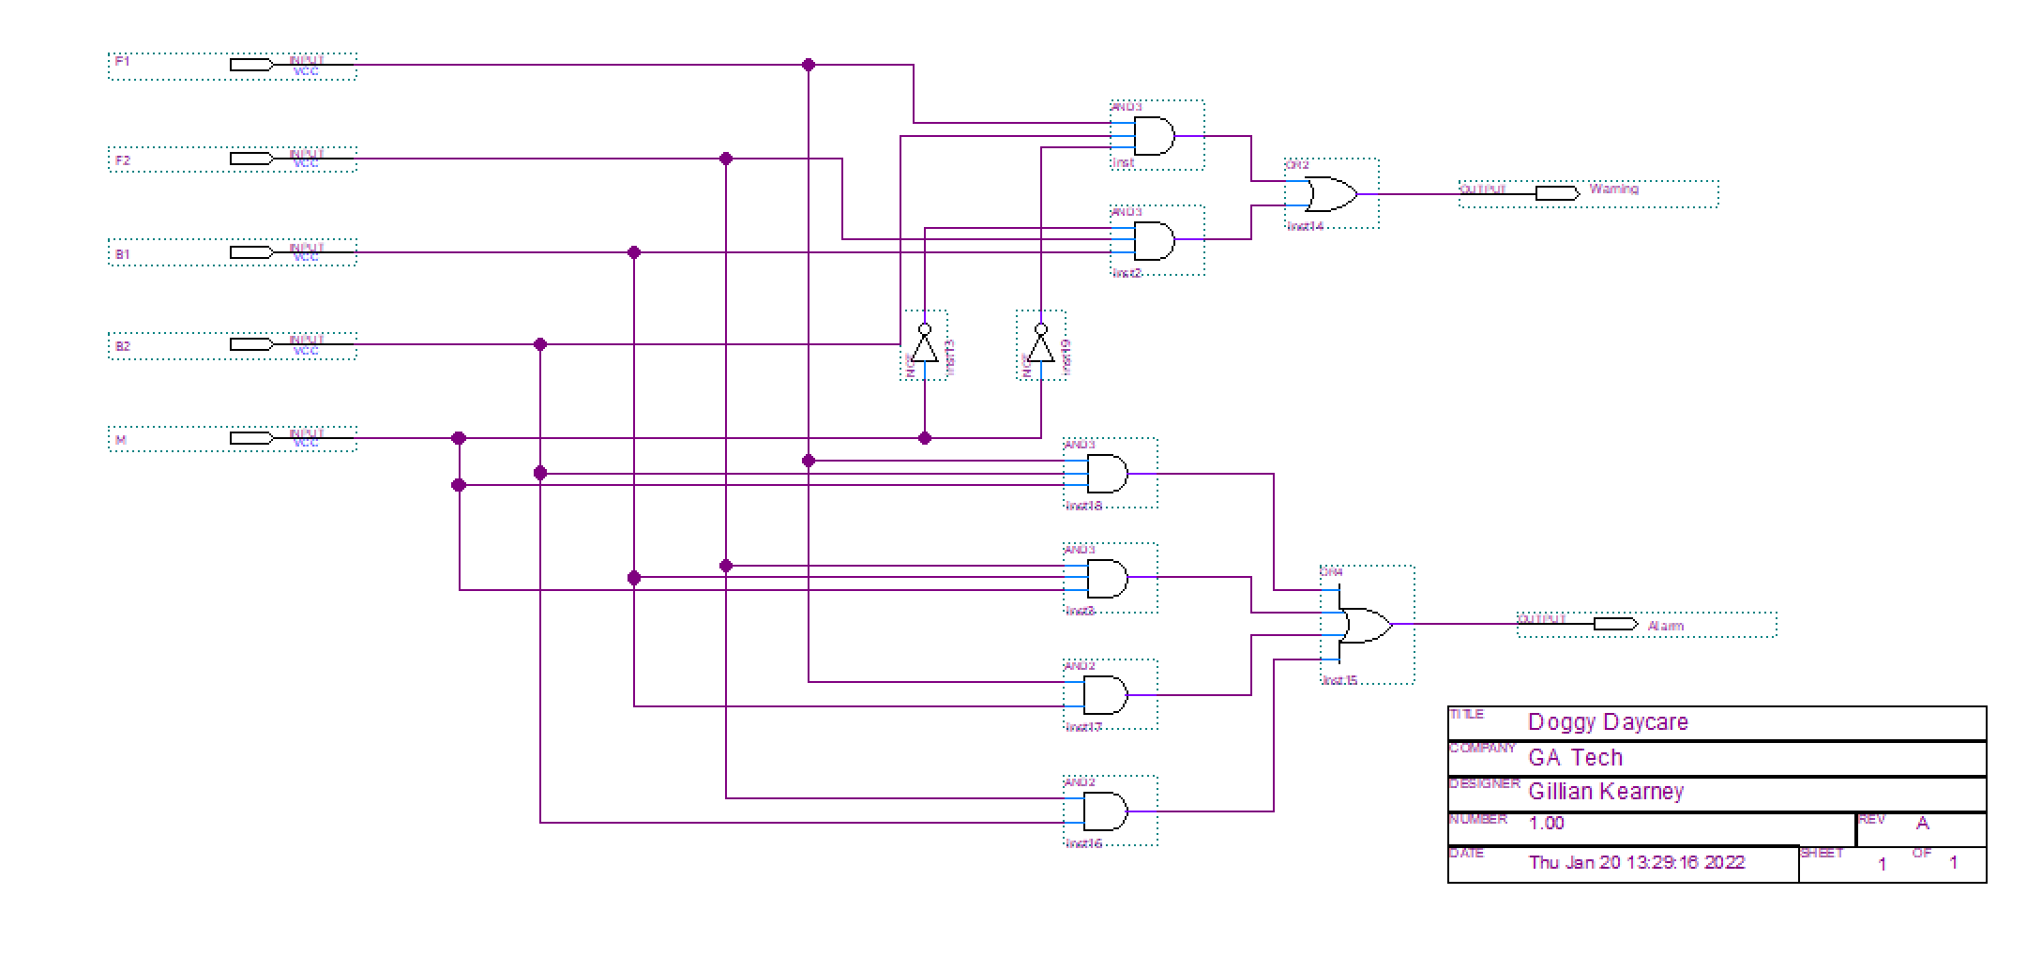

**Figure 1.** Circuit that activates an alarm and warning. The alarm output follows the following logic: Alarm = F1*B1 + F2*B2 + F2*B2*M + F2*B1*M. The warning follows: Warning = F1*B2*/M + F2*B1/M.

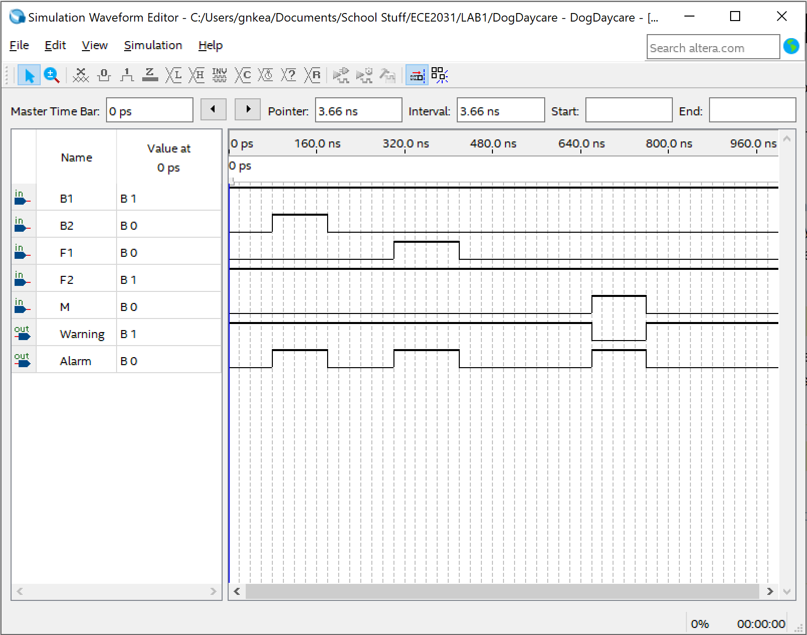

**Figure 2.** Functional simulation waveform implementing the dog alarm/warning system for a subset of all possible input combinations to determine the accuracy of the circuit.

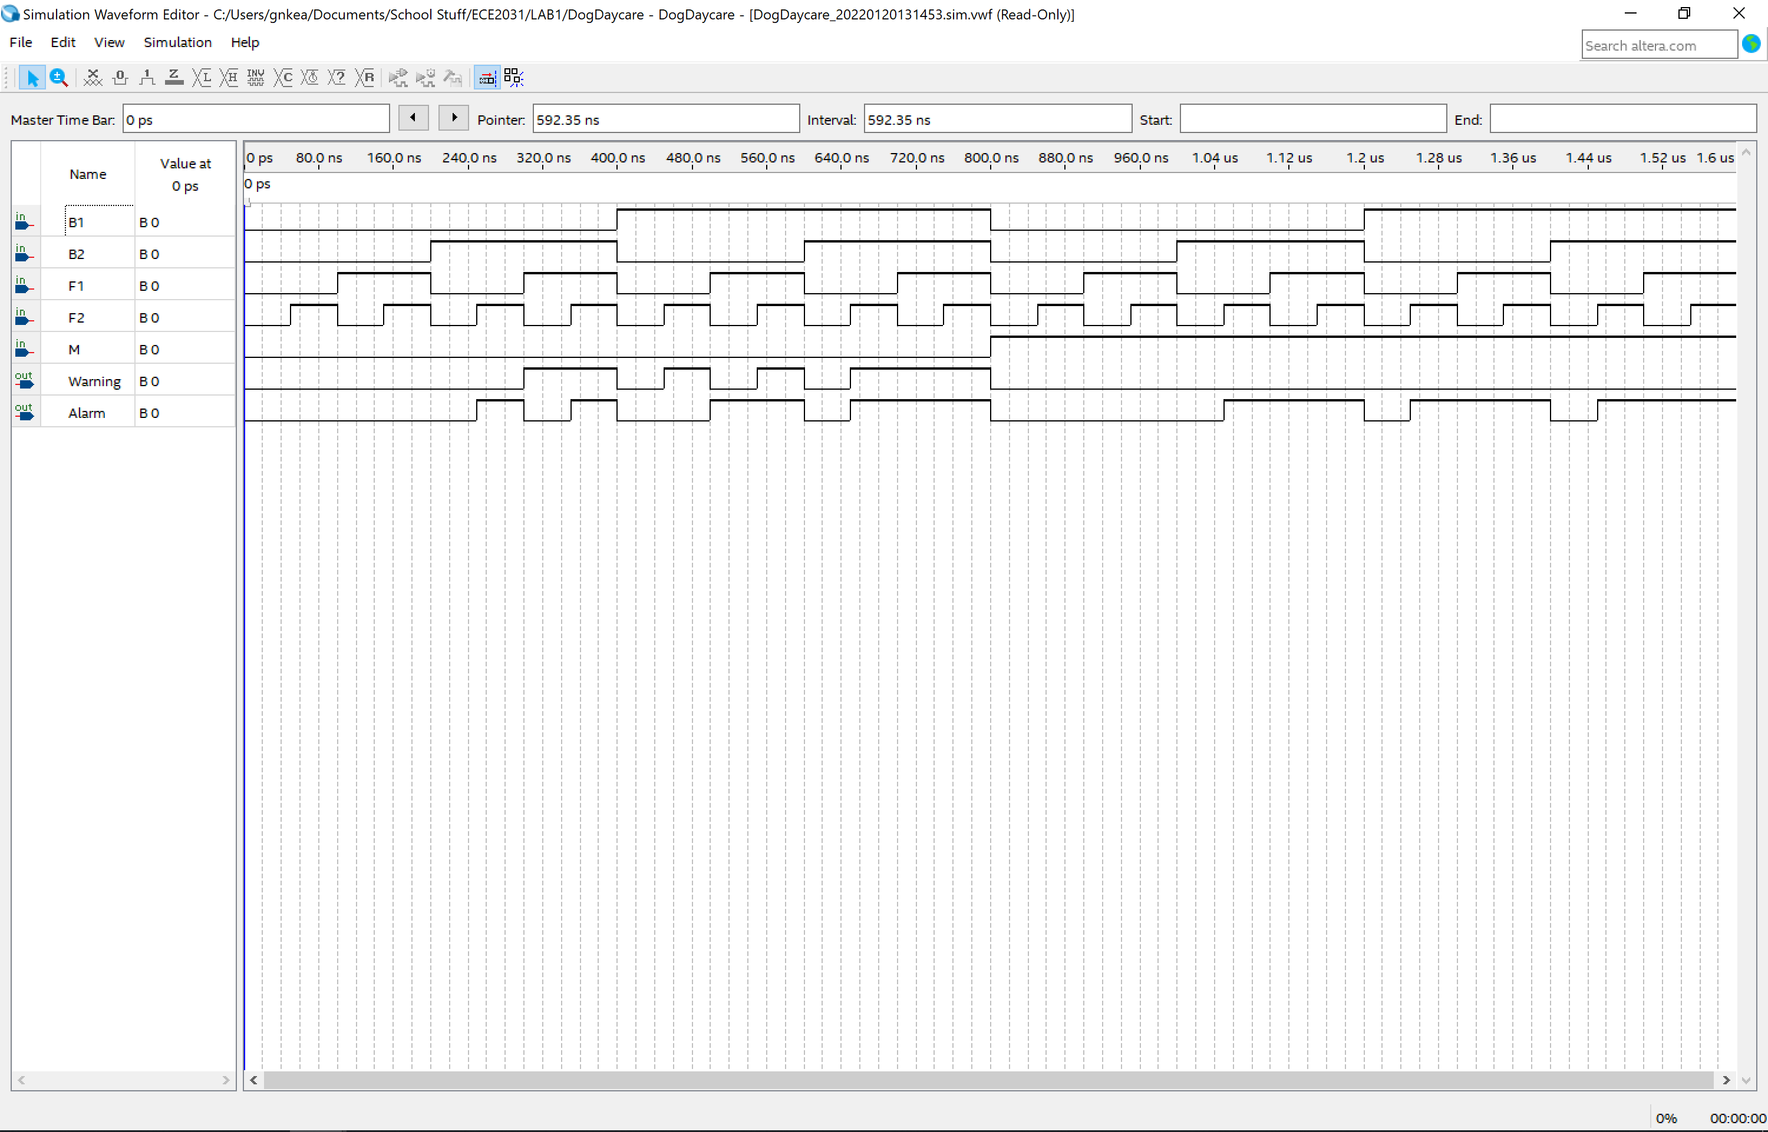

**Figure 3.** Functional simulation waveform implementing the dog alarm/warning system for all possible input combinations to confirm the accuracy of the circuit.

**Figure 4.** Circuit implementing the dog/alarm logic (Alarm = F1*B1 + F2*B2 + F2*B2*M + F2*B1*M Warning = F1*B2*/M + F2*B1/M ) with specified pin locations for both inputs and outputs.